# **Weekly Report – W4 Spring 2023**

## **Task & Problem**

1. Finish the remained coding work of TMTDyn package to animate both arms in the same frame and some of the post processing;
2. Focus on the backpack hardware to test which pneumatic chamber corresponds to which PIN No. and modify the code to use just 3 chambers for actuation;
3. Some other remained issues of TMTDyn package solved in the second meeting with the author.

## **Solution**

1. Update about TMTDyn package

Last week we have verified that the input forces and pressure can be successfully passed to related simulation functions (to work out the static and dynamic process), thus the two remained tasks for this week will be modifying the *anim.m* and *post_proc.m* to animate the motion and to plot the tip position change of the two arms.

Firstly we need to set another if-else sentence in the outer layer of *anim.m* to judge if some of the inputs are struct or cell, if not, the original code will be executed; otherwise, each input will be treated individually through a for loop and be mounted into different cells as outputs.

Then we need to identify which parameters decide the on and off of the animation process, because neither the animation nor the post processing has been triggered in the struct functions called, and it can be confirmed that the following ones controlling the animation.

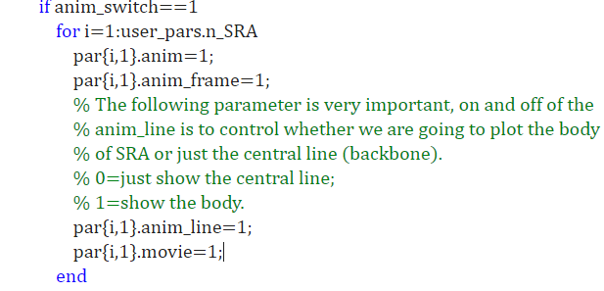

**Fig. W4-1** The parameters we have to change to activate the animation process for multiple SRAs

The logic of all the parameters mentioned above is 1 represents on and 0 represents off, especially for parameter *anim_line*, if it was set to be 0, only a central line or backbone of the SRA will be plotted and animated, which is not what we want; on the contrary, when it is set to be 1, the body of the SRAs will be displayed.

A minute issue of animation process is that recall that last week when the simulation code was executed no matter for animation process is on or off, there will always be a redundant blank figure show up, which is meaningless, so I added a close function to close the current figure for each loop which will not affect other figure plotting if we do not click our mouse, however, when it comes to the last iteration in the for loop, figure 1 will be plotted firstly showcasing the input information (if all the inputs are well defined in advance rather than in a feedback control) for each SRA, then the ODE solvers will begin to work to obtain the final results (more multiple arm simulation, the animation and post processing are put outside of the main for loop, because such functions have been deleted from the struct function called chain in *results* to avoid too many figures being plotted, which I have explained in the last week’s report), then the animation will be plotted both in the new figure (figure 2) and the last subplot figure in the previous $3×2$ figure frame.

The solution is that if we keep the blank figure in the last iteration of the main for loop, the last subplot figure recording the input information will not be overwritten.

The modification about *post_proc.m* is relatively easy, which is basically about changing the type of output data (similar to *anim.m*), and the final achievements are shown in the following figures.

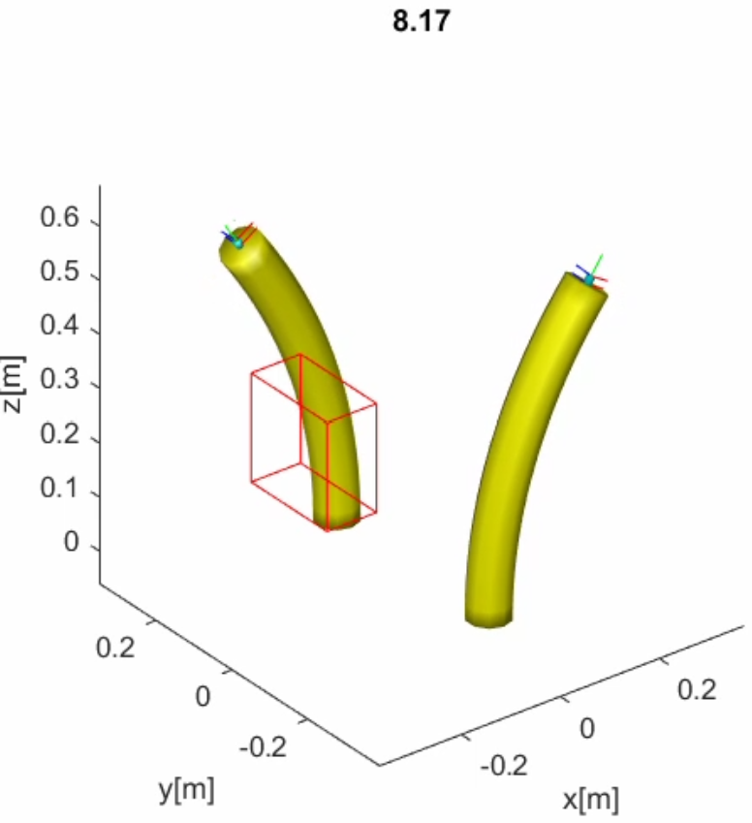

**Fig. W4-2** The screenshot of animation process at simulation time 8.17 s

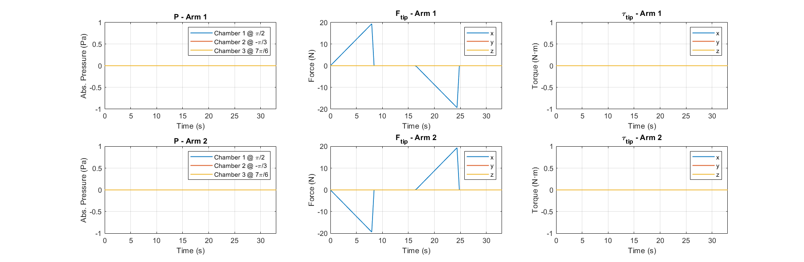

**Fig. W4-3** The input information of the test simulation

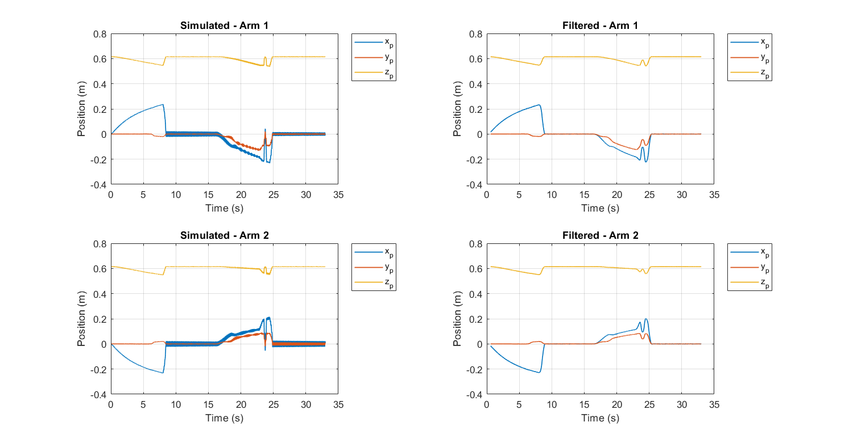

**Fig. W4-4** The output information (tip position of each SRA) for the test simulation

1. Update about backpack hardware

#### (1). Confirmation of each pneumatic chamber with respect to PIN No.

It could be a little hard to directly start from the mature code from Param, the first step is not for us to test if the code would work for the backpack, we should find out which PIN No. actuates which chamber first.

From the source code we can see that the PINs used were defined as follows,



**Fig. W4-5** PINs defined in the main function to actuate each chamber

then we are going to write our own code to test what the arm will behave with only one chamber pressurized for each time, and according to the definition in the dissertation, the left and right side was defined as follows. However, I don’t think it complies with ergonomics, we can change its sequence in the future.

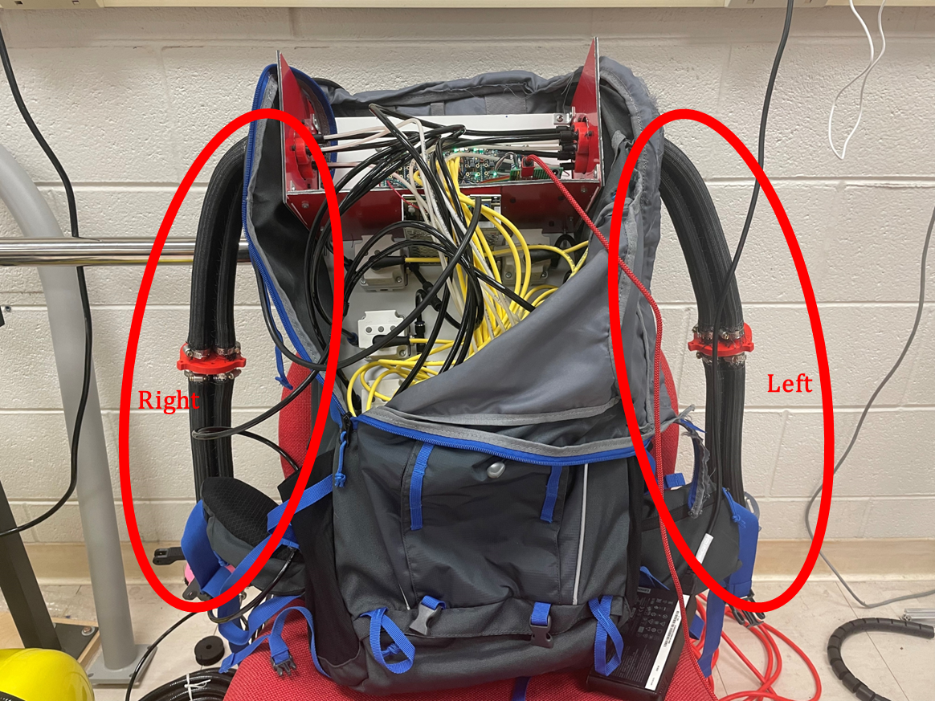

**Fig. W4-6** Left and right arm definition

After a series of tests, all the PIN numbers have been confirmed, which can be seen in the following two figures.

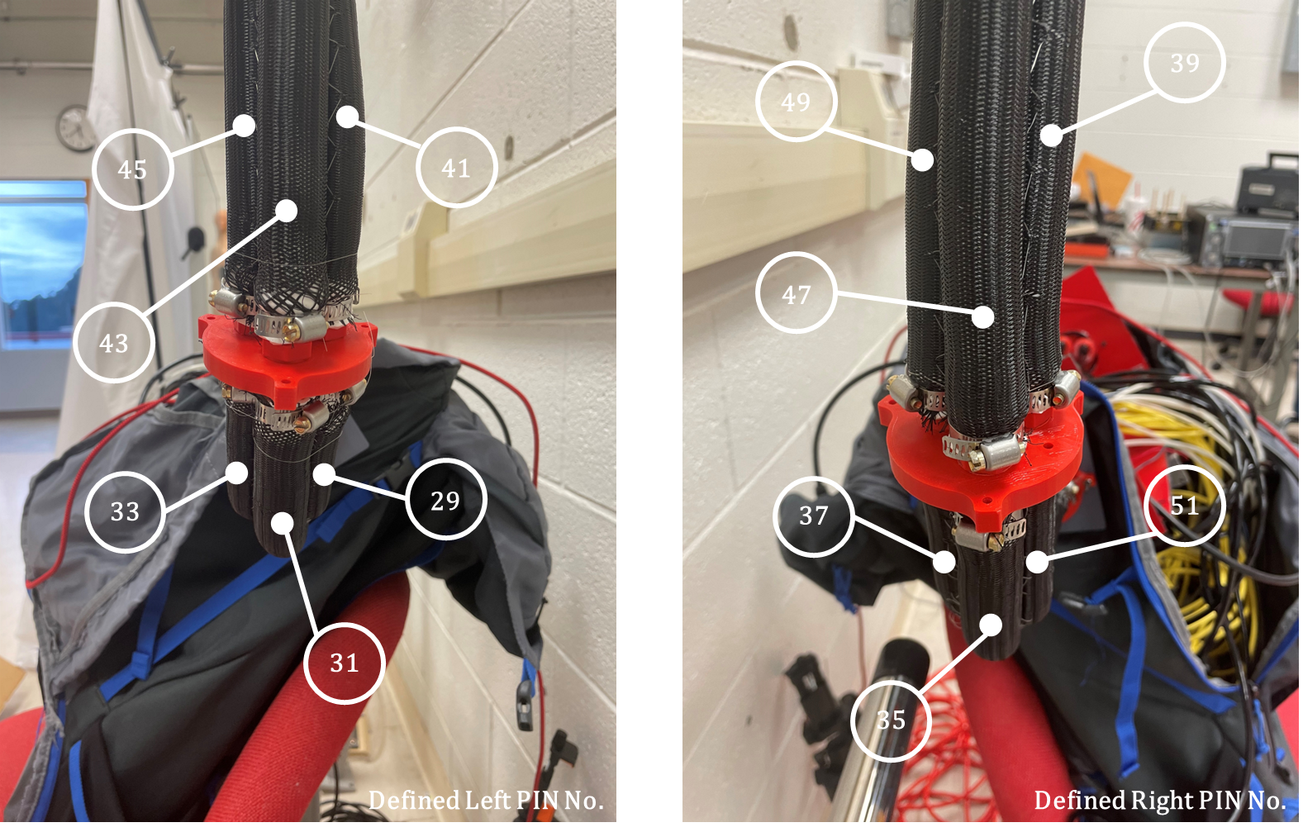

**Fig. W4-7** PIN No. for each chamber

#### (2). Pressurize just one chamber to see if the two segments will move in the manner as single arm

The conclusion is that the hypothesis is wrong, initially I thought that the proximal (which is closer to the base) segment has two elastic chambers inside, and one of them is connected to the distal (which is closer to the end effector), for example if we would like both segments on the left to lift up, we only need to supply pressure input in PIN 43 as shown in Fig. W4-6, however, in the individual tests in (1), we can clearly see from the video records that the proximal segment would not move, it still hung downwards to the ground; and since there are not any supported cross-section drawings for us to check what is the layout inside each chamber, we can only make such deduction as follows based on the type of tubes used for this device, as shown in the Fig. W4-6, there are basically three types of tube/cable in the backpack, the yellow ones are connected with the pneumatic pressure regulators to supply power to them; the very thin white tubes supply pressure to the proximal segments, and for the black ones, they supply pressure to the distal segments. The innovation of the inner structure of proximal segment is that the tubes inside to supply pressure to distal segment were designed to be in a spring shape with both ends well sealed as shown below.

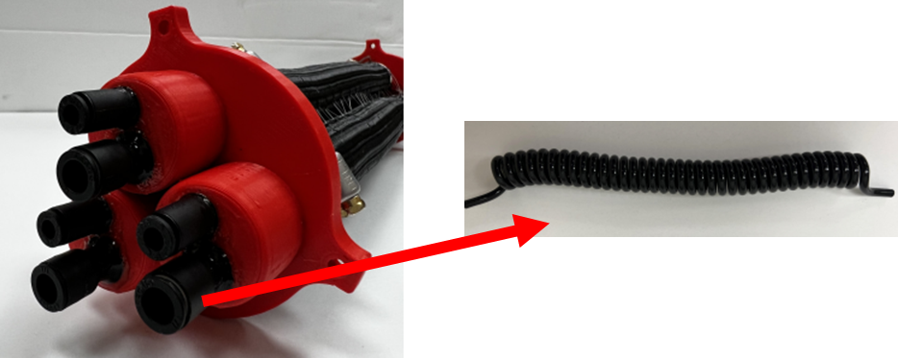

**Fig. W4-8** The inner structure for proximal segment

The advantage is that when the proximal segment was supplied with pressure, it will be stretched as well as being bended, if the tube inside in a straight and relatively solid one, this goal will not be fulfilled, so usually the proximal segments feel like being pressurized even though they are not.

So back to our topic, to realize that the two-segment arm behaves like a single segment arm, we must supply the same amount of pressure input to both distal and proximal segments, I have done tests for all the chambers and recorded videos (they all performed like an elephant’s trunk within our expectation), to eliminate the influence of self-gravity of the arms, I placed it onto the ground, below are the tests for right arm with PIN No. 49 and 37 from stationary state to 27 psi.

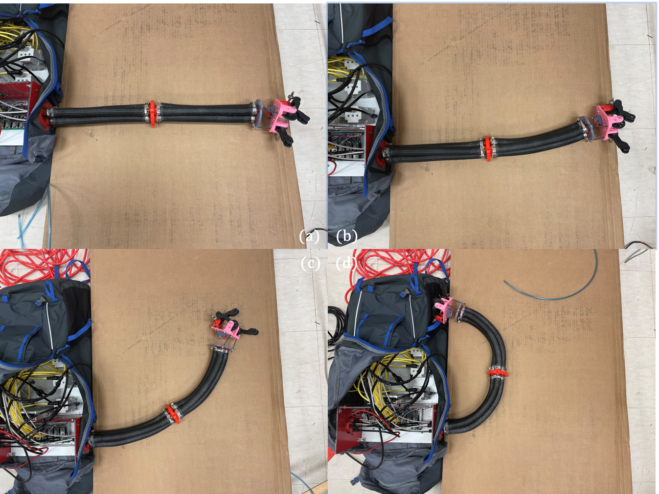

**Fig. W4-9** The deformation of the SRA on the right with different pressure supplies. (a) 0 psi, (b) 9 psi, (c) 18 psi, (d) 27 psi.

I set a relatively long delay time to allow me to record the position and deformation of the SRA for different pressure supplies, and before supplying pressure input, the position of the arm will always be initialized to the position and gesture shown in (a). We can see that when the pressure is smaller than 27 psi, they all performed like a beautiful and perfect curve (except for No. 39 and 51), however, when the pressure was increased to 36 psi, the arm was twisted seriously as below.

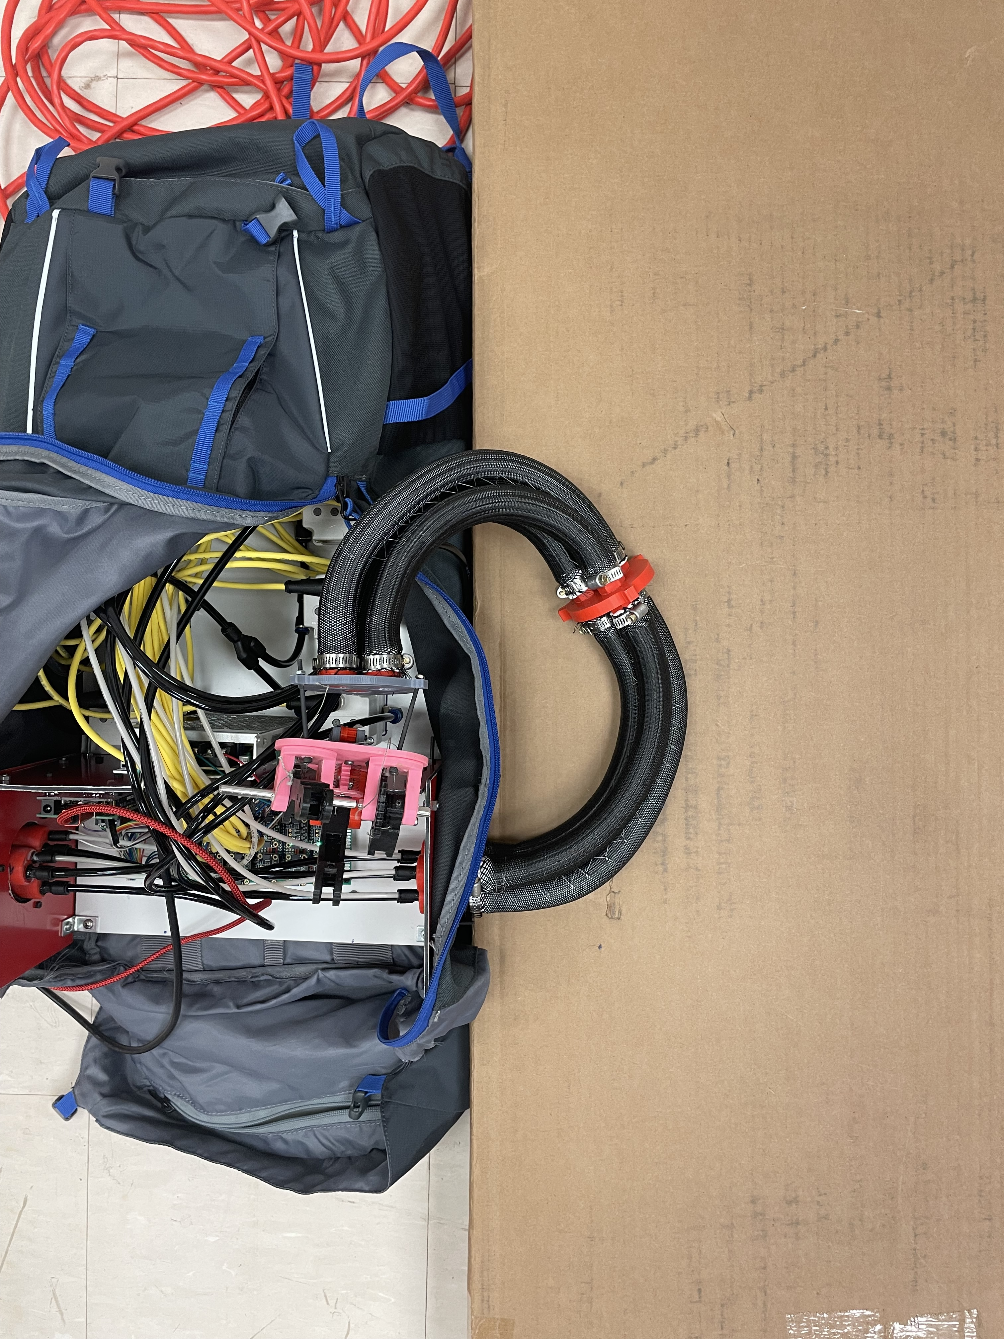

**Fig. W4-10** The deformation of the arm with PIN No. 49 and 37 under pressure 36 psi

#### (3). Estimate the curvature radius for each segment

To verify if the curvature for each arm is a constant, I measured the length of the arc and chord respectively (no so precise, which is limited by our existing tools we have now), the data is recorded in the table below; and reason for I just did for two connected chambers is that supplying pressure to No. 49 and 37 could make the arm move in the 2D plane perfectly, others are in 3D space, which made it hard to measure the lengths due to its gravity (gravity will also cause deformation).

**Table W4-1.** The arc and chord length for each segment for PIN No. 49 and 37 under different pressure supplies

|  |  |  |  |  |
| --- | --- | --- | --- | --- |
| **Pressure Input**  **Code/Real** | **Proximal Segment** | | **Distal Segment** | |
| Arc Length | Chord Length | Arc Length | Chord Length |
| 300/9 psi | 28.2 cm | 27.6 cm | 27.6 cm | 26.8 cm |
| 600/18 psi | 30.9 cm | 29.1 cm | 30.2 cm | 29.2 cm |
| 900/27 psi | 33.3 cm | 28.9 cm | 33.9 cm | 29.0 cm |

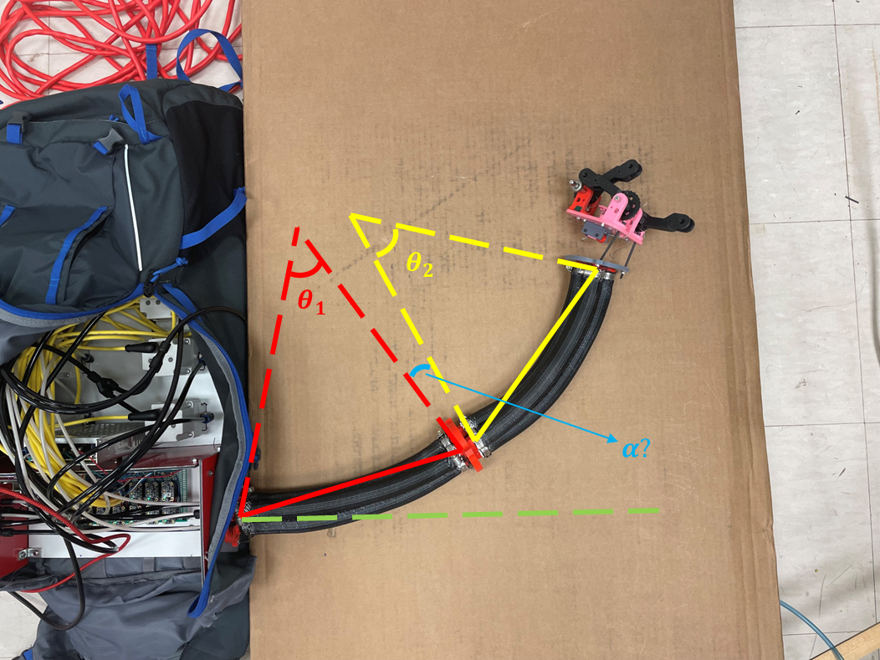

**Fig. W4-11** The schematic of curvature radius calculation

Based on the data, we can calculate the approximate curvature radius as follows,

$$\begin{aligned}\frac{θ}{2π}∙2πr=L_{a}\#\left(W4-1\right)\end{aligned}$$

$$\begin{aligned}r\sin{\frac{θ}{2}}∙2=L_{c}\#\left(W4-2\right)\end{aligned}$$

where $r$ is the approximate radius, $L_{a}$ and $L_{c}$ are arm and chord length respectively, associating both of the equations above, we have

$$\begin{aligned}r=\frac{L_{a}}{θ} → 2 \frac{L_{a}}{θ}\sin{\frac{θ}{2}}=L_{c} ⇔ \frac{\sin{\frac{θ}{2}}}{θ}=\frac{L_{c}}{2L_{a}}\#\left(W4-3\right)\end{aligned}$$

**Table W4-2.** The approximated radius calculated for each segment

|  |  |  |
| --- | --- | --- |
| **Pressure Input**  **Code/Real** | **Proximal Segment Radius**  **(cm)** | **Distal Segment Radius**  **(cm)** |
| 300/9 psi | 39.3366 | 32.9464 |
| 600/18 psi | 25.9019 | 33.7074 |
| 900/27 psi | 18.3170 | 17.7923 |

I’m not sure if the data has some reference value, maybe we need to some other more precise verifications in the near future.

#### (4). Some other issues during this week

* When pressurize only for No. 43, it turned out to perform like a “S” shape on Thursday, from the shape it seemed like No. 43 was connected with No. 33, but it didn’t make any sense and it was impossible. However, when Nithesh was coming for help on Friday, I run exactly the same code, it worked pretty well not in “S” shape, I was trying to duplicate the experiment on weekend, but it never happened again, I haven’t figured out the reason why;
* Air leakage is very serious on Thursday for No. 43, but when it come to Friday, it turned to normal again, still I haven’t figured it out why, maybe for one time I set the maximum pressure so high? But the pressure inside the compressor was not sufficient to achieve the target value, I don’t think that’s the real reason and I remembered I didn’t touched anything else on the regulators;
* When pressurizing No. 39 and 51, the shape is like below,

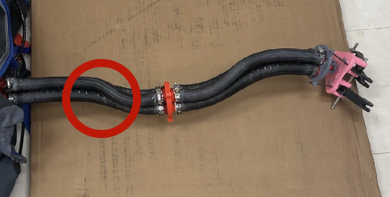

Fig. 4-12 The deformation for pressurizing PIN No. 39 and 51

since the movement was not in 3D space, so I lift them up to see whether both of the segments performed like a standard curve, for the distal one, it’s acceptable (I have the video record), but for the proximal end, it still deformed in “S” shape even if it was lift;

* Some of the fishing lines were loose due to the frequent experiments during the week, some of them even broke, I need to fix them next week.

1. Discussion about the remained problems with the author

#### (1). About the error of sqrt function with EOMs

I checked the previous weekly reports, sorry for my bad memory, this error only emerged when the real Young’s Modulus of the SRA in our project has not been confirmed, so the simulation package did run without any errors for all the tested input (500 N maximum input force exerted on the tip and 29 bar maximum pressure input for single chamber). However, it did have some errors for some specific settings, I have reported this situation to the author, he has never met this before, he will follow this up.

#### (2). About the odd displacement along y axis even if there is no force or pressure input in that direction

As explained by the author, this abnormal buckling might be caused by the step size of the ODE solver, we can either decrease the step size or try other solvers available (like some external solvers), things will be different. But anyway, it won’t affect the final results too much, the basic deformation tendency is correct.

#### (3). About the proper way to do simulation for multiple arms

He was totally shocked when he saw the animation I made for 2 arms, actually he never thought about simulation of multiple arms, he suggested me that I can establish new bodies still use the struct functions called instead of using for loop, a lot of parameters need to be fix, which is hard to explain it here (I have recorded a video of our meeting, I can check it anytime afterwards). He was not 100% sure about his method proposed, I’ll take a try in the near future. And he said if there is no interaction between the two arms, I can still use my solutions.

## **Plan**

* Focus on the backpack source code provided by Param, modify the code with two adjacent chambers pressurized with the same amount of pressure input according to our need;
* Do supplementary experiments when necessary.